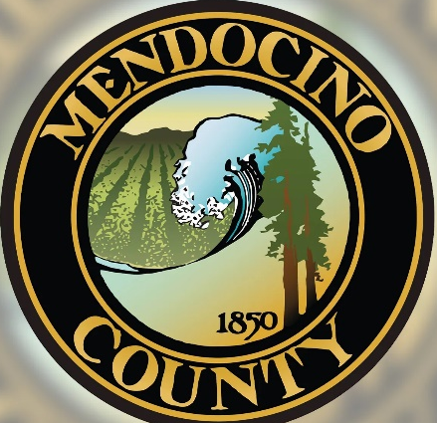
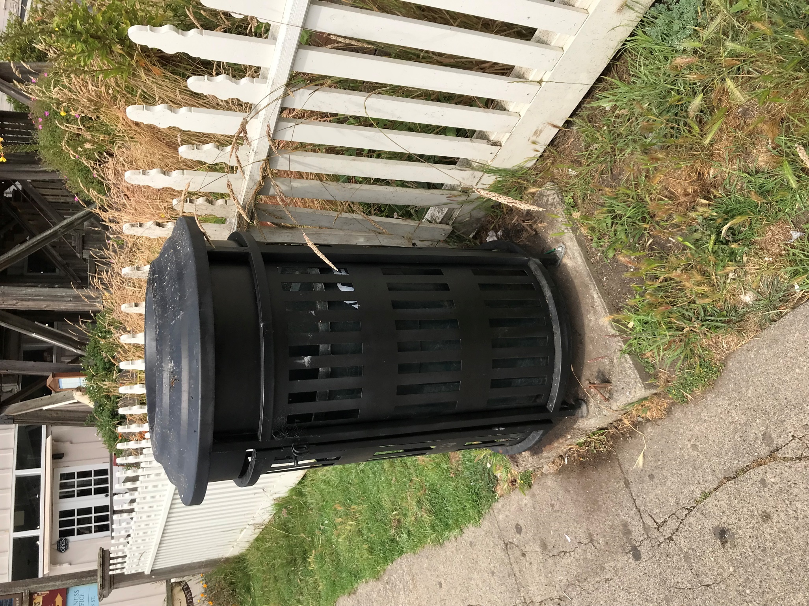
CONTACT:
COUNTY OF MENDOCINO
340 LAKE MENDOCINO DRIVE
UKIAH, CA 95482
707-463-4363
DOT@MENDOCINOCOUNTY.GOV
Mendocino
County
Adopt-A-Can

MENDOCINO COUNTY ADOPT-A-CAN PROGRAM
The Mendocino County Adopt-A-Can Program is a fun, rewarding, and worthwhile program that provides individuals, companies, and organizations an opportunity to volunteer within their community while saving taxpayer dollars. You can clean up a public trash can and beautify the Town of Mendocino in cooperation with the Mendocino County Department of Transportation Solid Waste Division (DOT SWD). This is a great way to promote civic responsibility, community pride, and camaraderie within your business or organization.

Who Can Participate?
- Individuals
- Organizations
- Businesses

Participate By:
- Check on your/your organization’s adopted trash can on non-collection days and collect any fugitive litter

You Make The Choice
You may do the work yourself, with a group of people, or you may hire a contractor.

You Get The Recognition
Aside from the satisfaction of contributing to positive change within your community, there is public recognition as well. If you desire, DOT SWD will install a recognition sign on your adopted trash can. Each sign will display your name or your business or organization name and indicate the nature of the work being performed.

Your Commitment
- Periodically pick up litter near your adopted trash can for two years at least once per week. Volunteers may choose to pick up litter more frequently if needed.
- Follow all safety and permit requirements.

County’s Commitment
- Loan volunteers litter picker tools and provide a box of latex gloves (latex free gloves available upon request).
- Provide volunteers with free trash bags and dispose of collected trash that will not fit in the adopted trash can.
- If desired, publicly recognize you or your organization or business free of charge.

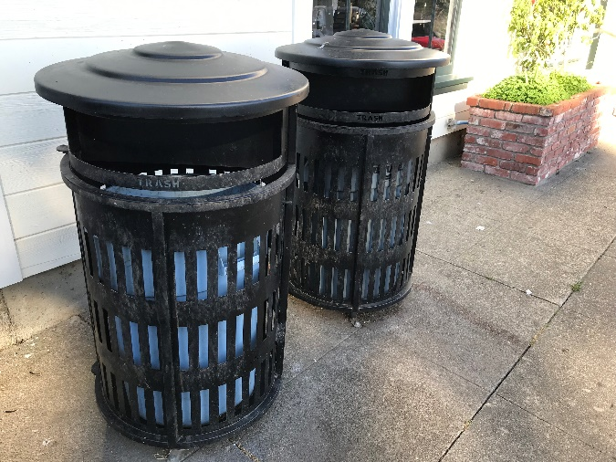
Which Cans Are Adoptable?
All on-street public trash cans in the Town of Mendocino will be considered for adoption.

How To Get Started:
- Identify the trash can(s) you would like to adopt.
- Contact the Mendocino County Adopt-A-Can Coordinator to determine if the trash can is adoptable.
- If your can is adoptable, complete an application and submit to the Adopt-A-Can Coordinator.

Once You Have Your Permit:
- Visit your adopted trash can(s) at least once a week on non-collection days and pick up fugitive litter.

- Contact the Adopt-A-Can coordinator immediately if collected fugitive litter will not fit in your trash can.

Permit Renewal:
- You can renew your permit as many times as you wish.
- Your permit cannot be transferred to another person. Change of Permittee will require submittal of a new application.

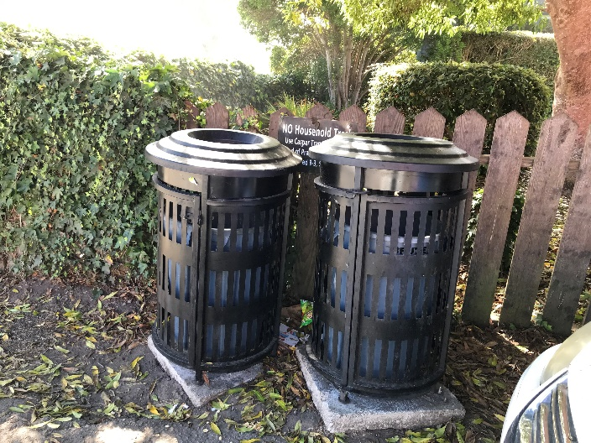

Let’s keep Mendocino beautiful together!

Ready to Adopt-A-Can?
Contact the Mendocino County Department of Transportation:

340 Lake Mendocino Drive
Ukiah, CA 95482
(707) 463-4363
dot@mendocinocounty.gov

